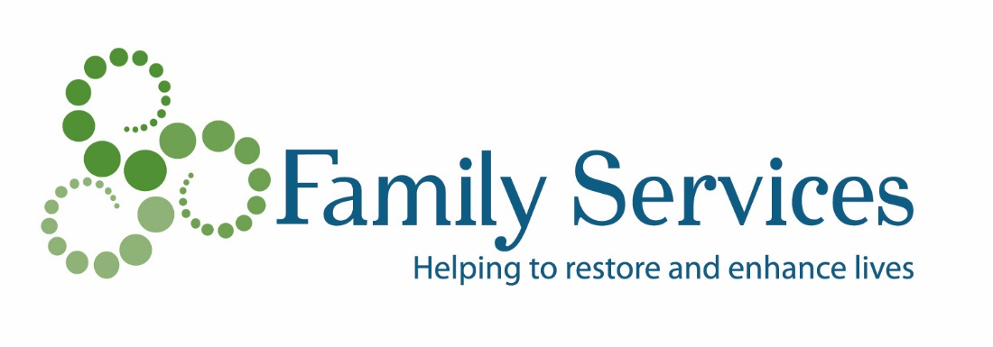
SAMPLE NOTIFICATION LETTER FROM DONOR REGARDING IRA QUALIFIED CHARITABLE DISTRIBUTION TO FAMILY SERVICES OF SOUTHERN WISCONSIN AND NORTHERN ILLINOIS, INC.
Date
Pamela Prescott
Resource Development Director
Family Services of Southern Wisconsin and Northern Illinois, Inc.
416 College St.
Beloit, WI 53511
Re: Qualified Charitable IRA Distribution to Family Services
Dear Pamela,
It is my pleasure to inform you that I have requested a qualified charitable distribution from my Individual Retirement Account payable to Family Services of Southern Wisconsin and Northern Illinois, Inc. in the amount of $ ________ [any amount up to $100,000] from my plan trustee/administrator, ____________________________ [name and contact number for IRA trustee/administrator].
Please use my gift to Family Services for the following purpose: ____________________ [gift designation, if any].
It is my intention that this IRA rollover gift comply with the “qualified charitable distribution” requirements of Sec. 408(d)(8) of the Internal Revenue Code. Accordingly, upon your receipt of payment from my IRA trustee/administrator, please send me a contemporaneous written acknowledgement that states the amount of my gift, that no goods or services were provided to me by Family Services in consideration for this gift, and that my gift will not be placed in a donor advised fund or supporting organization. Even though I will receive an acknowledgement of this distribution, I understand that there is no federal charitable income tax deduction for this distribution.
If you have any questions or need to contact me, I can be reached at ______________ [your telephone number] or ____________________ [email address].
Sincerely,
[IRA Plan Owner/Donor]
We would be happy to answer any questions you may have about this information. Please call Pamela Prescott, Resource Development Director, at (608) 365-1244.

